National Service Scheme - NSS
The National Service Scheme (NSS) is an Indian government-sponsored public service program conducted by the Ministry of Youth Affairs and Sports of the Government of India. Popularly known as NSS, the scheme was launched in Gandhiji's Centenary year in 1969. The program is designed to provide help to everyone who needs it, enhancing the standard of living and fostering a life of dignity for the community.
Institutional Heritage
Our college NSS UNIT has been permanently affiliated with Bengaluru Central University since 1995. For nearly three decades, the unit has been actively involved in regular activities and special social events under both State and Central projects. Our volunteers have earned distinction by participating in various State and National Camps, including NIC, PDP, and NYF.
Vision and Mission
- Vision: To build the youth with the mind and spirit to serve society and work for the social upliftment of the down-trodden masses as a national movement.
- Mission: To develop the personality and character of the student youth through voluntary community service. Our core purpose is "Education through Service."

- Aim and Motto
The motto of the NSS is "Not Me But You." This reflects the essence of democratic living and upholds the need for selfless service. NSS helps students develop an appreciation for other points of view and show consideration toward all living beings.

GOVERNANCE & CORE ACTIVITIES
ADMINISTRATION AND PROGRAMMES
NSS Advisory Committee
The unit operates under the guidance of a dedicated administrative body:
- Principal & Director: Dr. Vijayashree L
- Program Officer: Mr. Yallappa M
- Advisory Members: Dr. Mohan Rao, Mr. Sharavana, Mr. Guranna, and Ms. Shailaja
Student Leadership (2025-2026)
- President: Shwetha L
- Vice Presidents: Anand Vardhan Lal, Vipin S Gowda
- Secretary: Deeksha N Shetty
- Joint Secretaries: Madan Kumar M, Vaishnavi SH
- Department Heads:
  - Cultural: Ranjan A (Head), Lavanya D & Jnanika J (Secretaries)
  - Organizing: Akash Gouda HM (Head), Chandra Adithya C (Secretary)
  - Technical: Dhanushree S (Head), Ayush Biswakarma (Secretary)
  - Treasury: Samrudh M (Head), M Yojith Reddy (Treasurer)
- 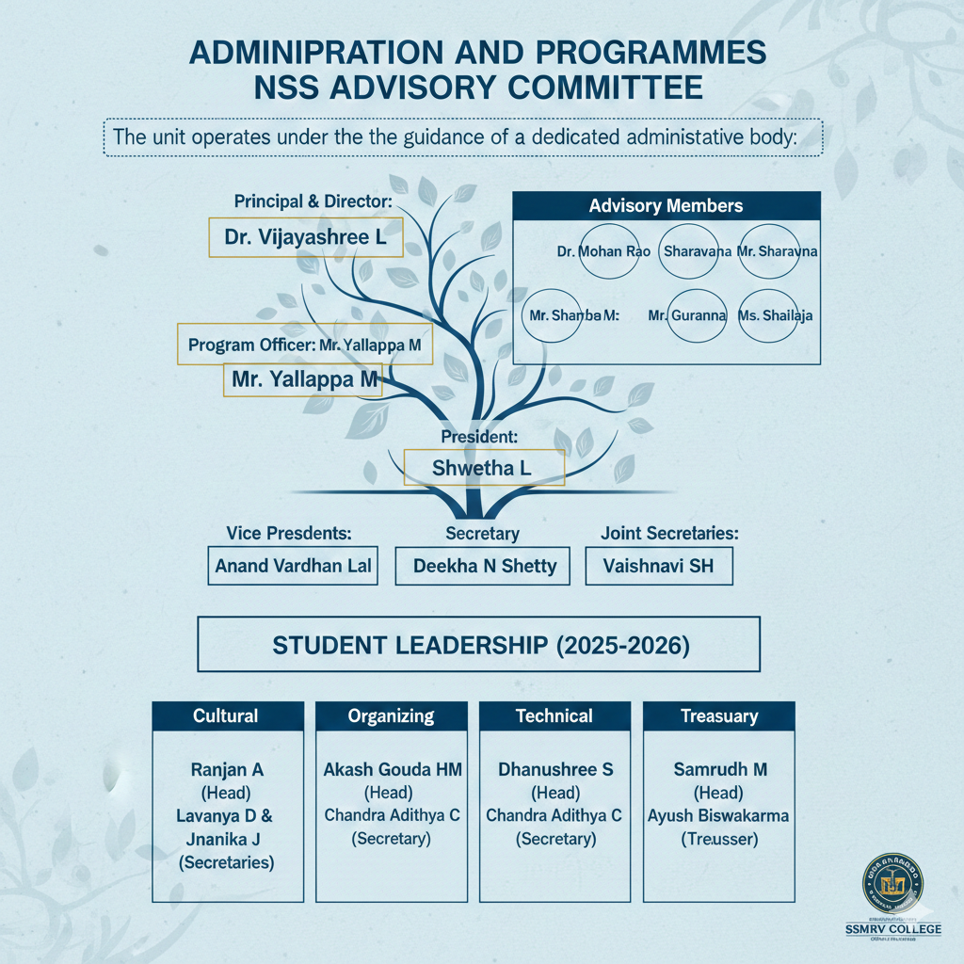

Activity Category | Description
Plantation | Environmental conservation through tree planting initiatives.
Health & Blood Donation | Community health checkups and life-saving blood donation drives.
Awareness Programs | Educational campaigns on HIV/AIDS and social awareness.
Commemorative Days | Celebrating Gandhi Jayanthi, Ambedkar Jayanthi, and NSS Day.
Specialized Camps | National Integration Camp (NIC), Republic Day (RD) Camp, and Personality Development Camp (PDP).
Regular and Special Camp Activities

RECOGNITION & ACADEMIC CALENDAR
AWARDS AND ANNUAL CALENDAR 2025-26
Awards and Recognitions
Our unit is proud of its history of excellence at both National and State levels:
- National Level: NSS National Award, Indira Gandhi National Award, and RD Camp Parade (New Delhi).
- State/University Level: Best Volunteer State Award, State RD Parade, and BCU Recognition Certificate.
- Educational Benefits: NSS volunteers are eligible for a 2% special quota in Higher Education.
Calendar of Events (Academic Year 2025-26)
Sl No | Programme | Tentative Date
1 | Independence Day | 15/08/2025
2 | NSS Day Celebration | 24/09/2025
3 | Gandhi Jayanthi Celebration | 02/10/2025
4 | Mega Blood Donation Camp | 10/10/2025
5 | Life Skills Training Program (NIMHANS) | 31/10/2025
6 | Constitutional Day | 26/11/2025
7 | World AIDS Day | 01/12/2025
8 | National Youth Day | 12/01/2026
9 | Republic Day | 26/01/2026
10 | NSS Annual Special Camp | FEB-2026
11 | International Yoga Day | 21/06/2026

