Activity Report
Academic year 2025-26 (June 2025 - May 2026)

Name of the Activity | GST 2.0 Redefining India’s Tax Landscape
Date | 22/09/2025
Time and Venue | 11:30am to 12:45pm, Seminar hall, SSMRV College
Mode (Online/Offline) | Offline
Web Link | NA
Organized by  Name of the Department / Activity Centre | Accounting and Taxation Club  Department of Commerce
Event Coordinator/ Faculty In-charge | Ms. Vidya U Jambagi
Student Coordinator | NA
Nature  Academic /Co- curricular/extracurricular/others | Academic
Topic Name | GST 2.0 Redefining India’s Tax Landscape
Resource Person Details  (Name, Designation and Organization/Institution) | Dr S R Keshava  Senior Professor, Department of Economics, Bangalore University
No. of Participants  A)External  B)Internal | 70
Objectives of the activity | - To understand the reforms of GST 2.0 in Indian economy  - To understand the effect of GST 2.0 on Consumers, Business and Government
Outcome of activity | - Students understood about the new tax rates, its classification and implication on goods and services  - TheyUnderstood the importance of GST 2.0- Two Slab tax structure

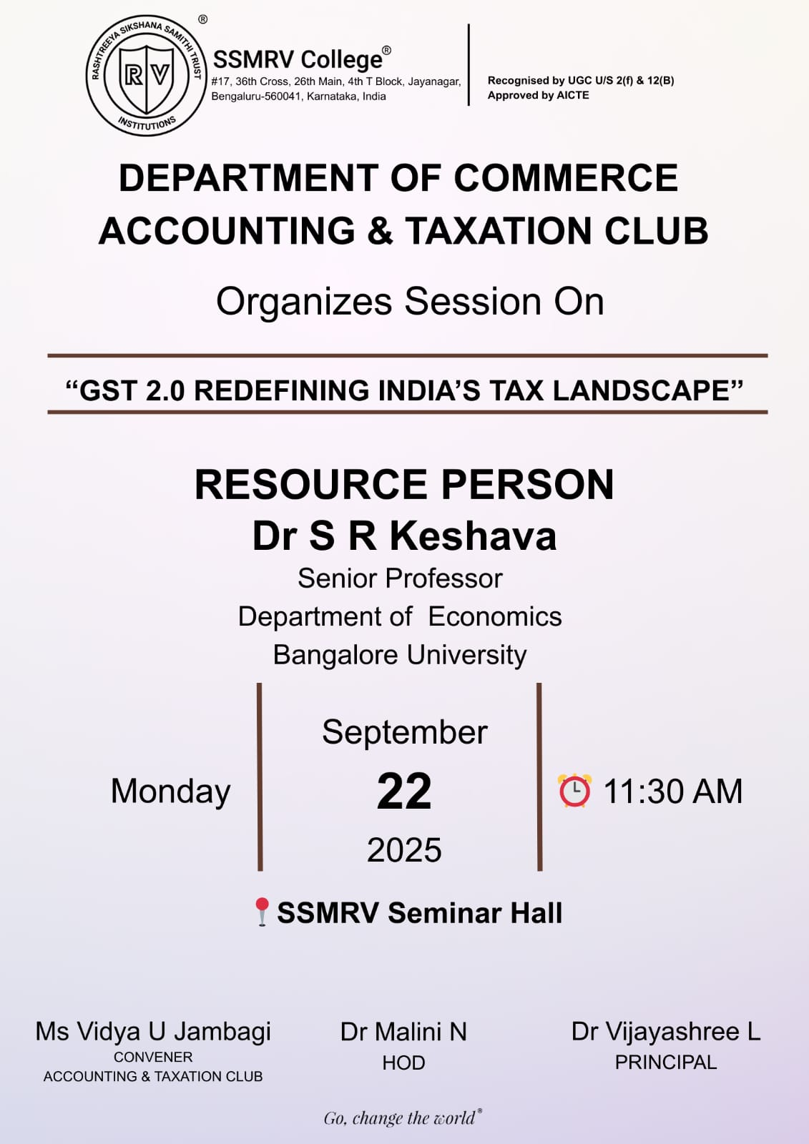

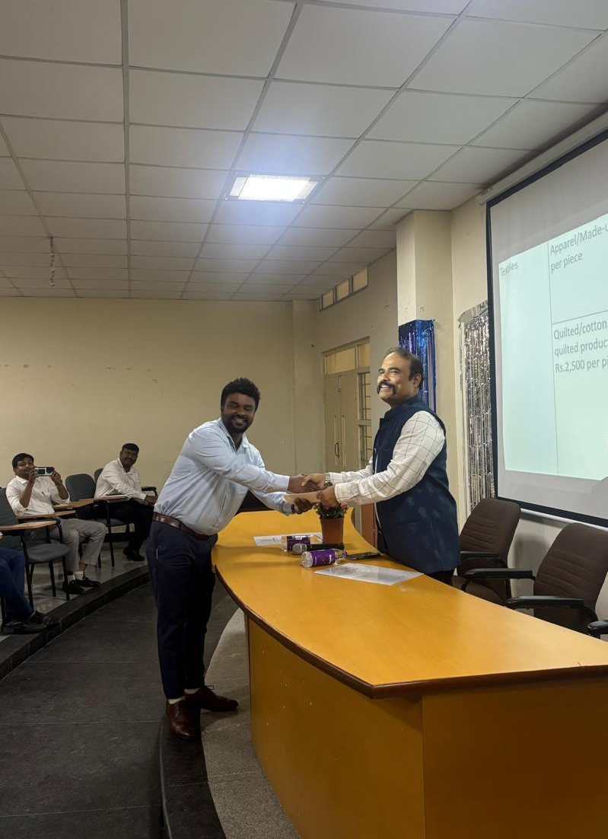
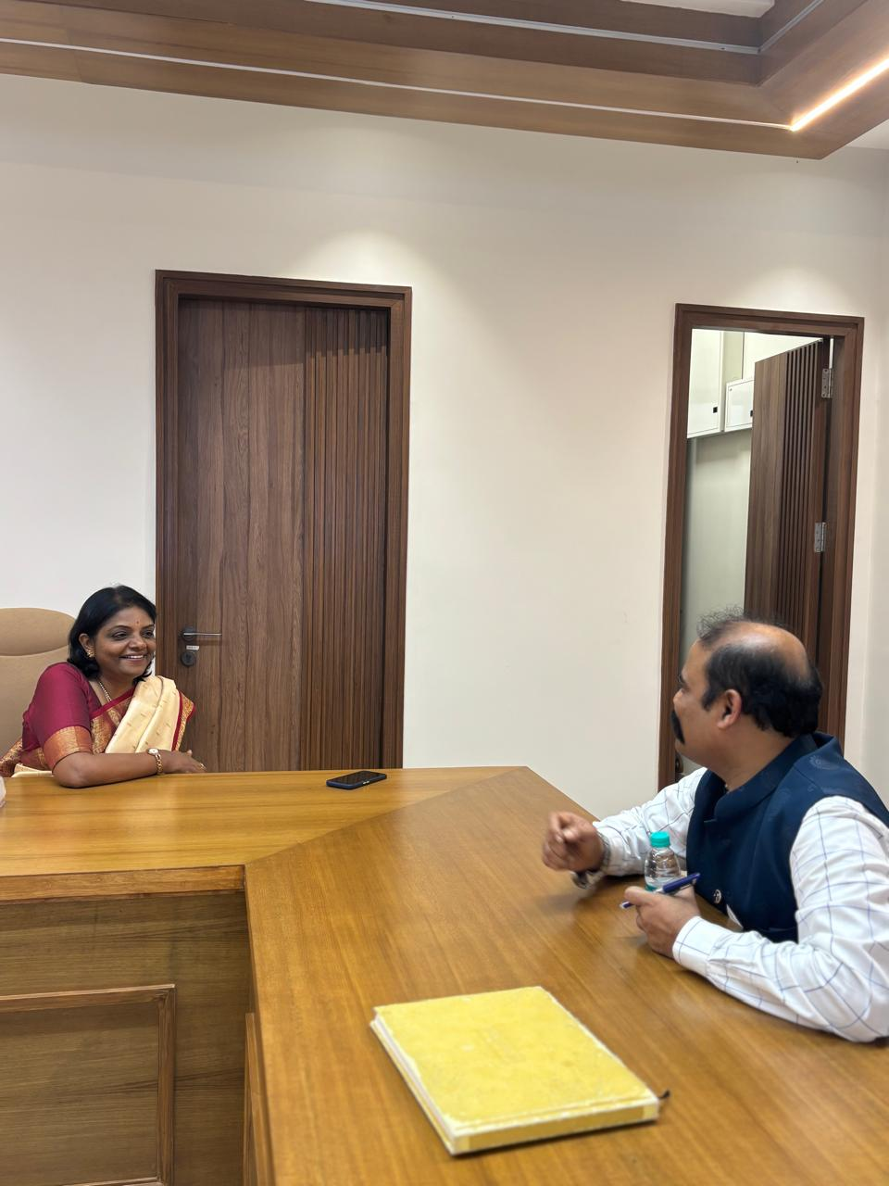
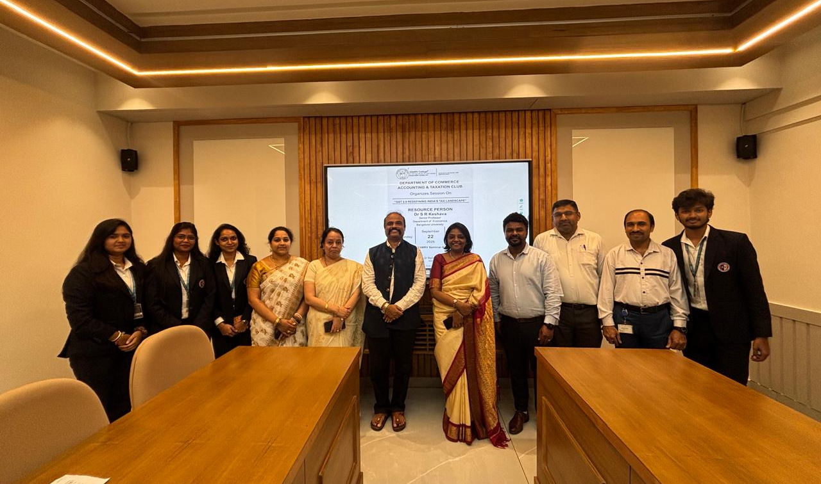
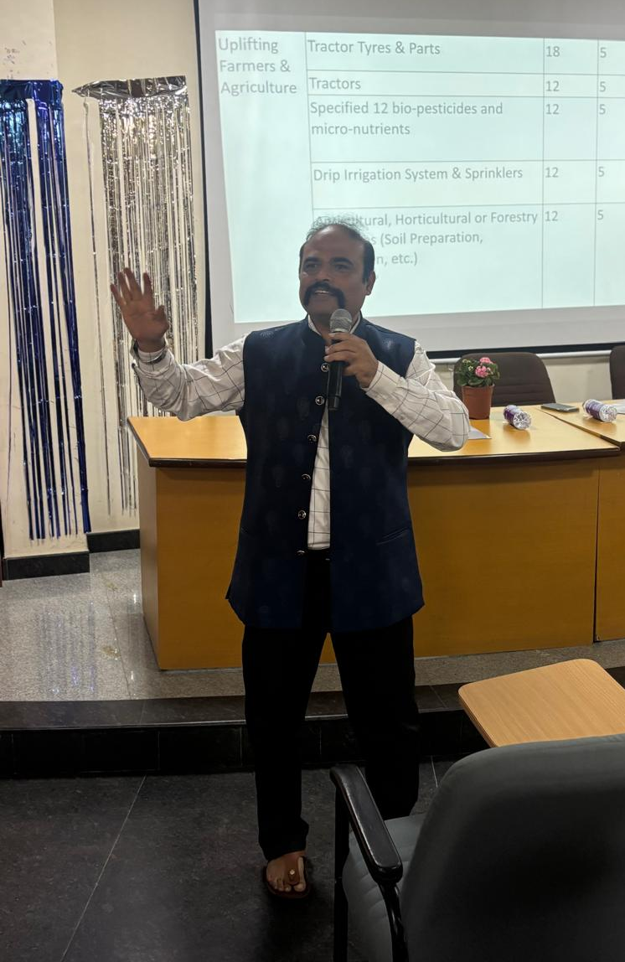
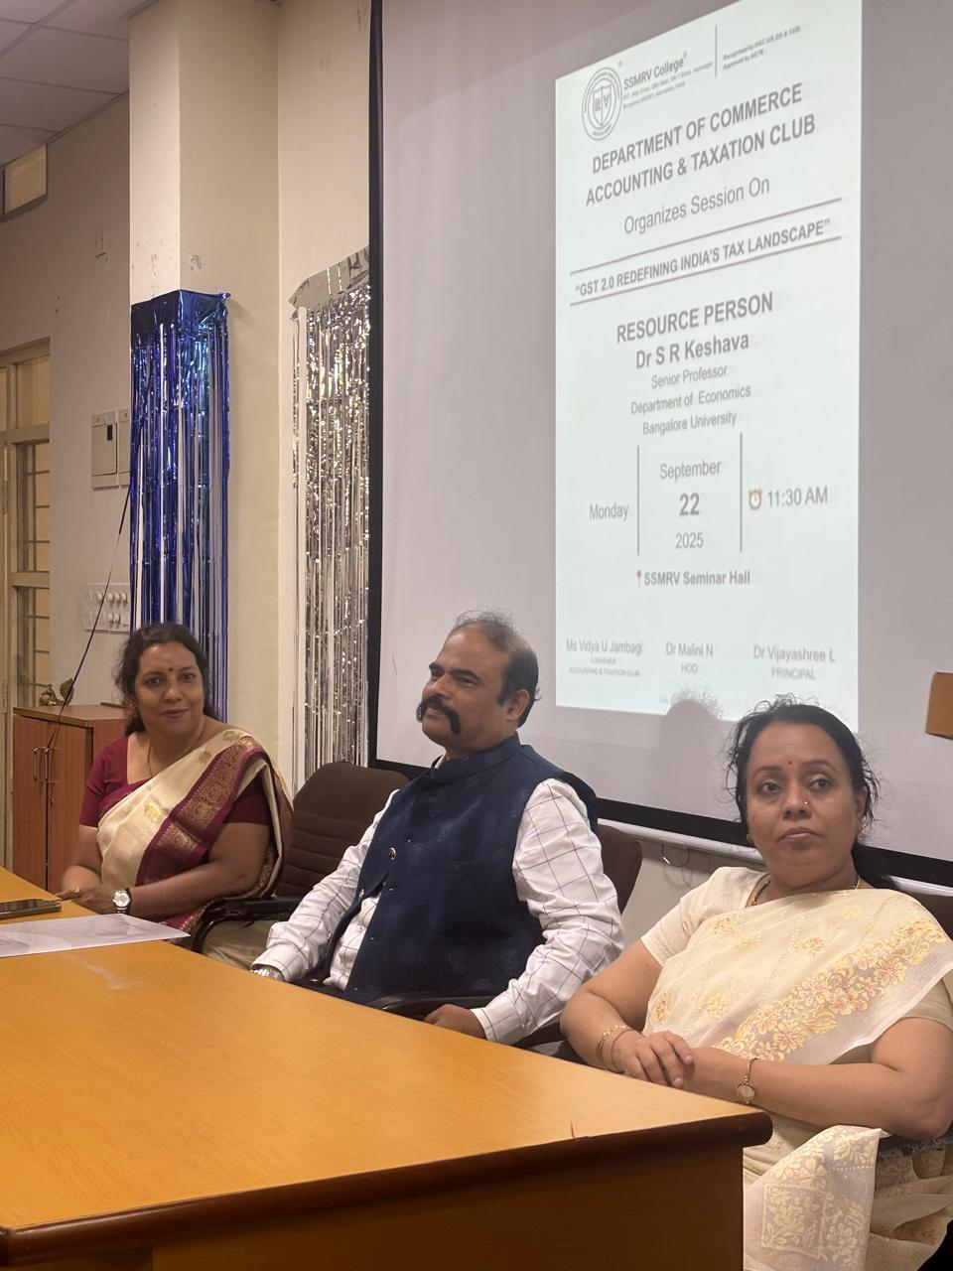
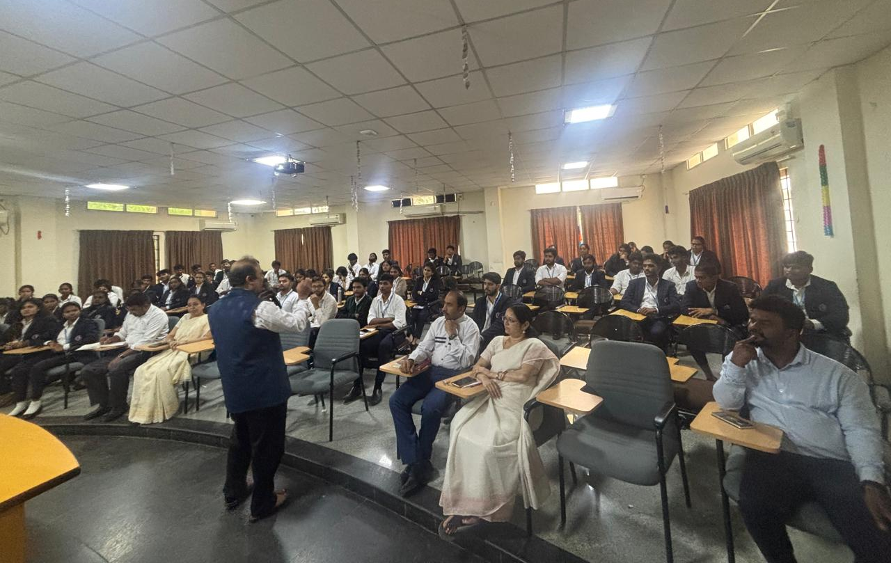

List of students who have attended the session “GST 2.0 REDEFINING INDIA’S TAX LANDSCAPE” on 22/9/2025
1. Vinitha A
2. Sanjana G
3. Shalini S
4. Preethi R
5. V Parinitha
6. Vandhana R
7. Rashmi T S
8. Shwetha R
9. Navya E
10. Bhanupriya R
11. Sinchana K S
12. Rosy B
13. Trisha K
14. Uma Maheshwari k
15. Yashaswini S
16. Nandini R N
17. Pavithra V
18. Sanjana Y
19. Supriya L
20. Rajiv Srivathsa N
21.Udhay Kumar V
22. Sunil Kalasada
23. Sumukha Rao
24. Prashanth R
25. Sujan M S
26. Shankar D
27. Karthik S
28. Murari S
29. Yashwanth R
30. Nishanth R
31. Yashwanth J S
32. Kalyan S
33. Pavan Joshi R
34. Santhosh S
35. Sagar C K
36. Pavan N
37. Sharath R
38. Sri Ram N
39. Yashas M
40. Rishi B G
41. Sridhatri R
42. Durga Sathish
43. Bhoomika S B
44. Ramya C
45. Spandana S
46. Manasa H
47. Shyam M
48. Sunil
49.Shezam Pasha
50. Salman Khan
51. Vipin
52. Vinay
53. Sricharan
54. Nagarjuna N
55. Varun B L
56. Umesh L
57. Pavan U
58. Vijay Praveen M
59. M D Owaiz
60. Raiyyan Basheer
61. Sultana Begum A
62. Shiva Subramanya S
63. Roshan Sahani
64. Mohammed Jasir
65. Usman
66. Akshay
67. Nagendra
68. Saif Syed
69. Divya J
70. G S Charan Tej

