Activity Report
Academic year 2025-26 (June 2025 - May 2026)

Name of the Activity | Over view of GST reforms
Date | 24/09/2025
Time and Venue | 11:30AM to 1 PM, RVIM Conference hall
Mode (Online/Offline) | Offline
Web Link | NA
Organized by  Name of the Department / Activity Centre | Taxation and Accounting Club  Department of commerce
Event Coordinator/ Faculty In-charge | Mrs. Vidya U Jambagi
Student Coordinator | NA
Nature  Academic /Co- curricular/extracurricular/others | Academic
Topic Name | Overview of GST reforms
Resource Person Details  (Name, Designation and Organization/Institution) | Mr. Subaraya M Hegde  Former Joint Commissioner, Commercial taxes, Bengaluru
No. of Participants  A)External  B)Internal | 137
Objectives of the activity | - To Provide the clear understanding of the new tax reforms, their personal financial impact and broader economic effects
Outcome of activity | - Provided practical understanding of India’s modernized tax system, equipping them with relevant skills and knowledge for their future careers.

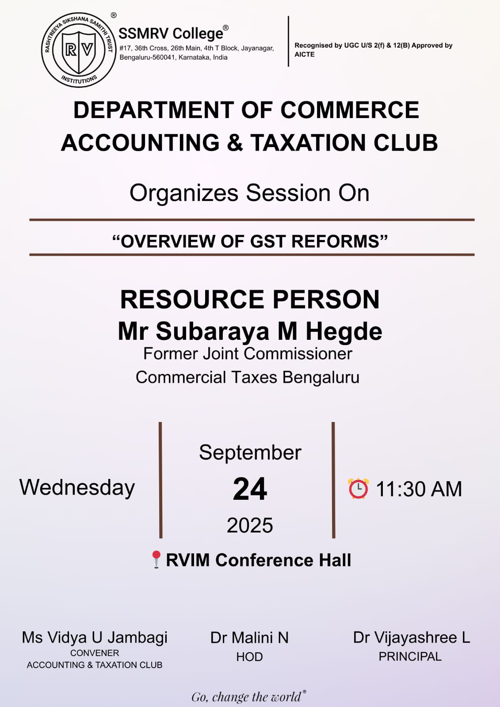
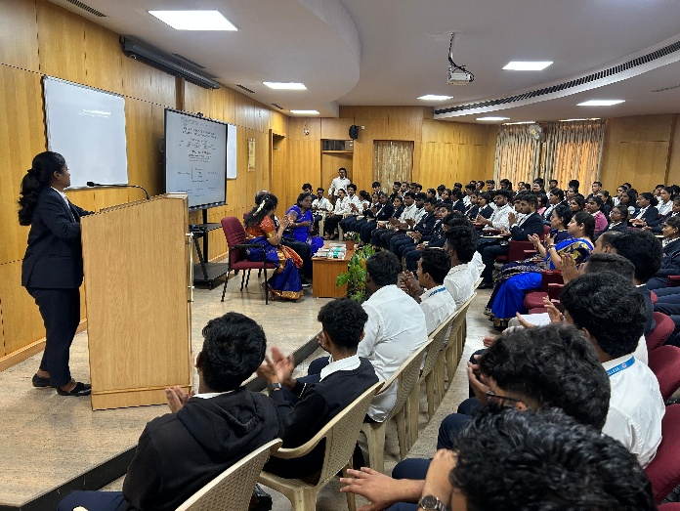
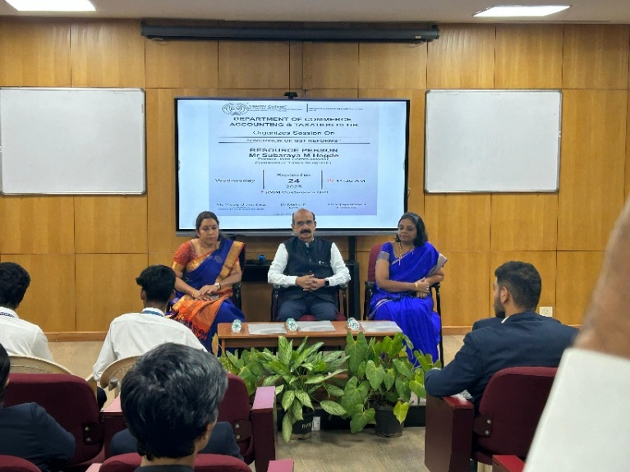

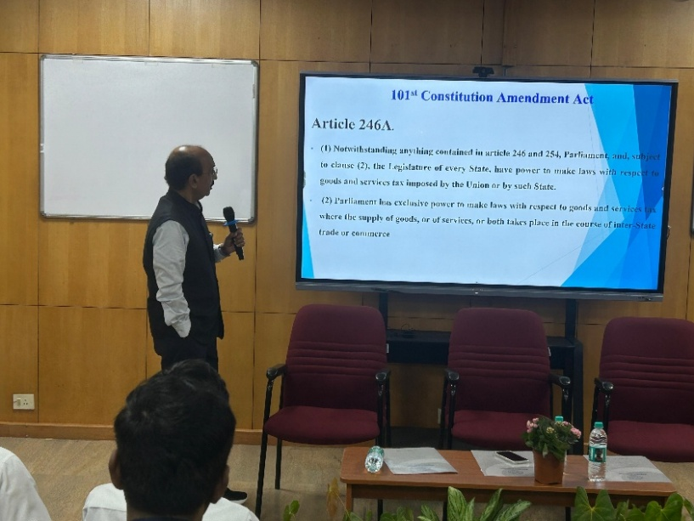
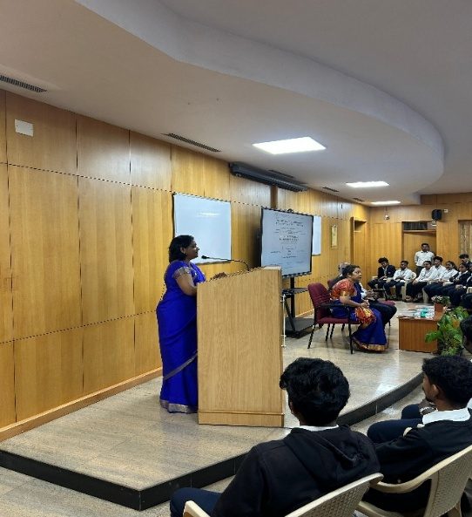

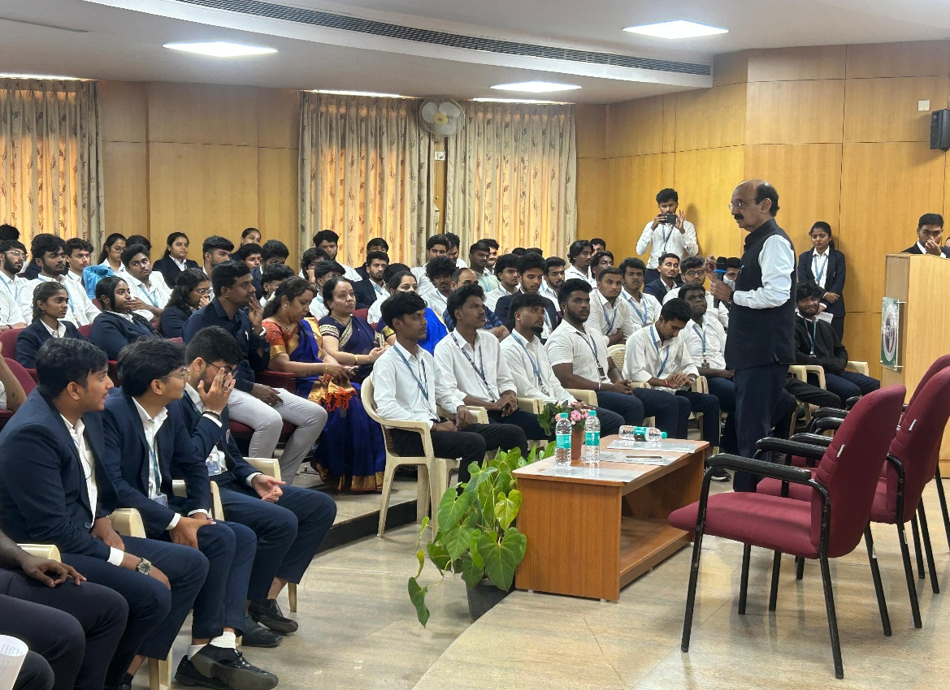

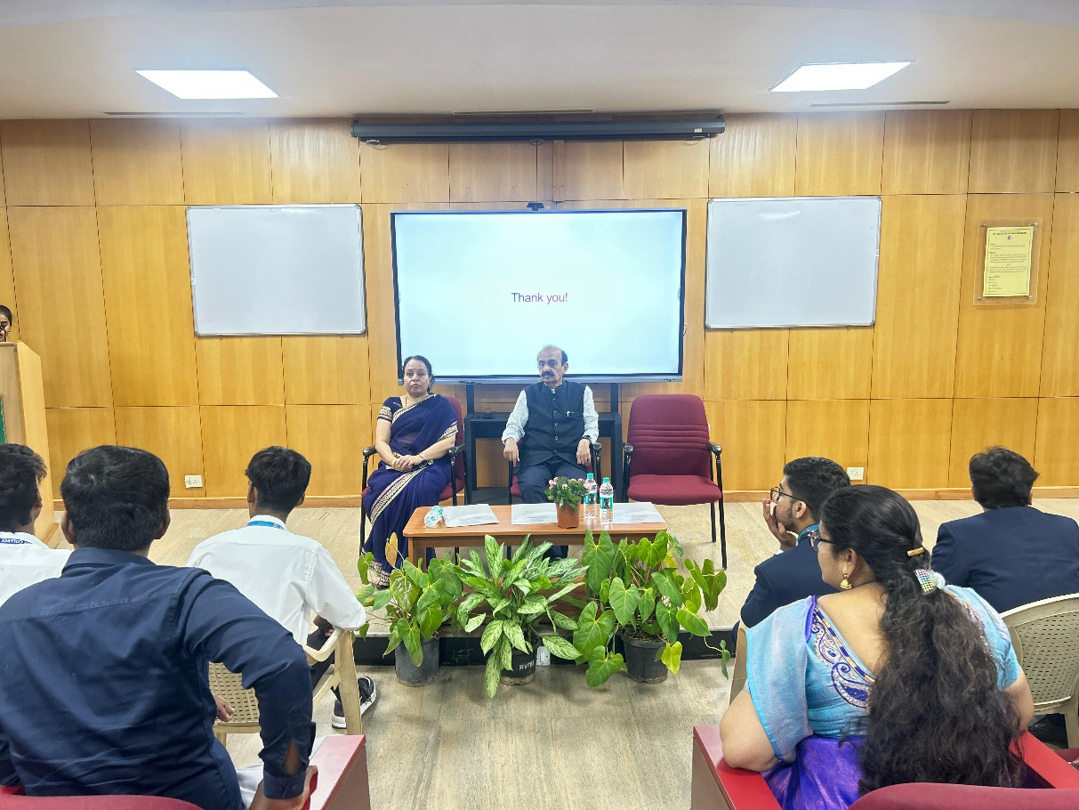
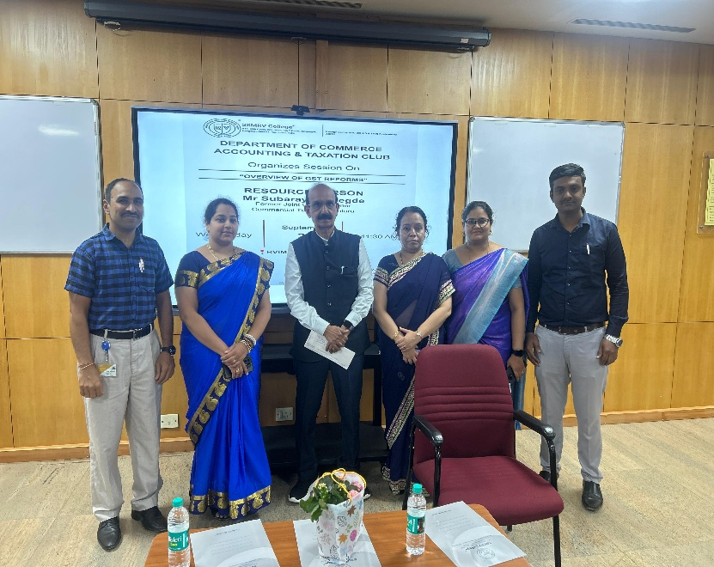

List of Students who have attended GST session “Over view of GST reforms” on 24/09/2025
1.Abhilash
2.Abhishek M S
3.Adhikeshav Reddy
4.Anagha R Dath
5.Anupriya M
6.Ashwini M
7.Bhanuprakash
8.Bhoomika Murthy
9.Bhuvaneshwari
10.Chandan Prasad
11.Charitha B
12.Charvi
13.Cheathan H
14.Cheathana A V
15.Deepak B
16.Deepak Kumar
17.Dhaksha
18.Dhanush
19.Dinakar
20.Divya
21.Eshwar
22.Gagana
23.Gopika
24.Gritha N
25.Harshitha
26.Harsha S V
27.Harshith Gowda
28.Hemanth G
29.Hemashree U
30.Himesh S
31.Irena Sara
32.Jeevika
33.Jeevitha
34.Karthika
35.Keerthana
36.Kiran G
37.Kiran S R
38.Krupashree B A
39.Lavanya Aradhya
40.Lavanya L
41.Lohith Reddy
42.Manasa H S
43.Rakshith
44.Sahana K
45.Darshan P
46.Vijay Yadav G
47.K L Hari
48.Vishal kumar gowda
49.Sanjay Samson
50.K Mohan Raj
51.Prajwal P
52.Vishal
53.Akash Gowda K M
54.Shashank R
55.Vandana S
56.Swathi S
57.Vikas M
58.Tarun S T
59.Yogesh R
60.Vinod S
61.Kiran G J
62.Yashaswini Raja
63.Bhoomika P
64.Devika
65.Dhruva D
66.Madhunandan
67.Mohammad Ziyad
68.Vikas V
69.Mallareddy
70.Basavaraja S
71.Durgesh R
72.Navya Sri
73.Ananya K R
74.Vivitha N
75.Ashwini K
76.Bhumika N G
77.Koushik E
78.Jagadeesh
79.Venkatesh
80.Disha Shetty
81.Disha M
82.Manjunath V
83.Lijith
84.Ullas Gowda
85.Manohara
86.Manoj
87.Vinay
88.Inchara
89.Sushmitha
90.Sujan
91.Manikraj
92.Aishwarya
93.Bhoomika N M
94.Manasa R
95.ChandraBabu
96.Koushik Eshwarnaik
97.Manushree N
98.Manya U Patre
99.Megan L
100.Megha G
101.Meghana Vshetty
102.Navanith Kr
103.Naveen B
104.Nishchith B
105.Nishitha M Adiga
106.Pallavi Ks
107.Pavan S
108.Pavan S
109.Pawani
110.Poojitha
111.Poorvaj T
112.Pournima Y
113.Prabha M
114.Prabhavathi J
115.Pragna N
116.Pranav S
117.Pravin Kaanth A
118.Puneeth N
119.Rakesh M
120.Rakshay S
121. Rakshitha
122.Ramesh M
123.Ranjan Joys
124.Ranjitha C
125.Rashmi K S
126.Rishika E V
127.Sachin Kumar M
128.Sai Manjunath D
129.Sai Akshatha Nm
130.Sai Kumar D
131.Sanjay K
132.Sanjitha Shree
133.Shanvi S
134.Shreeja M
135.Shushruth Gowdas
136.Siddaraju D
137.Sindhu J

