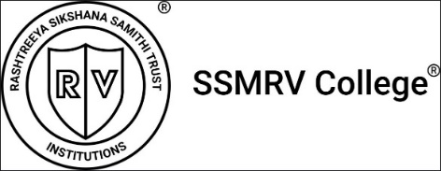
Activity Report
ACADEMIC YEAR 2026-27
1.BASIC DETAILS
Name of the Activity | BREATH ENERGY AND MINDFULNESS SESSION
Date | 04-August-2026
Time and Venue | 11:45 AM; Seminar Hall SSMRV College
Mode ( Online/Offline) | Offline
Organized by:  Name of the Department/Activity Centre | NATIONAL SERVICE SCHEME(NSS UNIT)
Event Coordinator/ Faculty In-charge | Mr. Yallappa M  NSS Program Officer
Nature:  Academic /Co- curricular/extracurricular/others | Extracurricular / NSS Annual Camp 2024-25
Topic/Activity | Breath Energy And Mindfulness Session
Resource Person Details  (Name, Designation and Organization/Institution) | Mrs. Manchaleswari Mahendra  Certified Meditationer
Participants | 85 Volunteers ( BCOM, BBA, BCA, BBA Aviation)
Objectives of the activity | The objective of the BREATH, ENERGY AND MINDFULNESS Session, organized by THE NSS UNIT OF SSMRV College, was to promote mental well-being, stress management, self-awareness, emotional balance, and concentration among college students. The session aimed to introduce students to simple breathing, meditation, and mindfulness practices that could be incorporated into their daily lives for a healthier and more balanced lifestyle.
Methodology | The session was conducted through an Interactive And Experiential Approach, including an introduction to mindfulness and mental health, guided breathing exercises, meditation, relaxation techniques, and awareness practices. Students actively participated in the exercises and were encouraged to observe their thoughts, emotions, and breathing patterns. The session concluded with reflection and discussion on the practical application of mindfulness in academic and personal life.
Outcome of activity | The session created greater awareness among students about the importance of Mental Health, Stress Management, And Emotional Well-Being. Participants gained practical knowledge of breathing and mindfulness techniques and experienced a sense of relaxation and calmness. The programmer encouraged students to adopt positive habits, improve concentration, manage everyday stress, and develop greater self-awareness as part of their overall personal development.

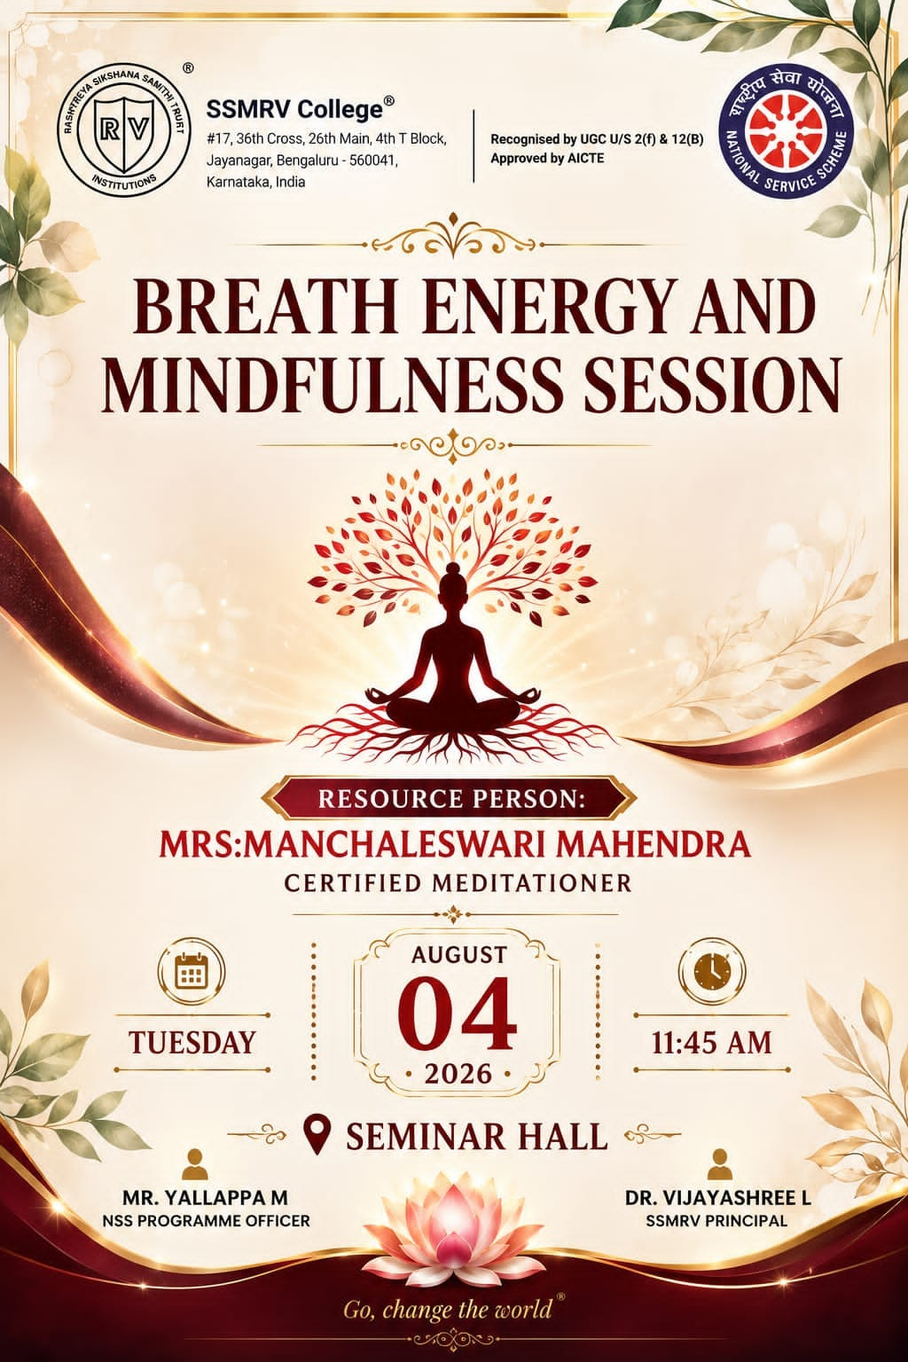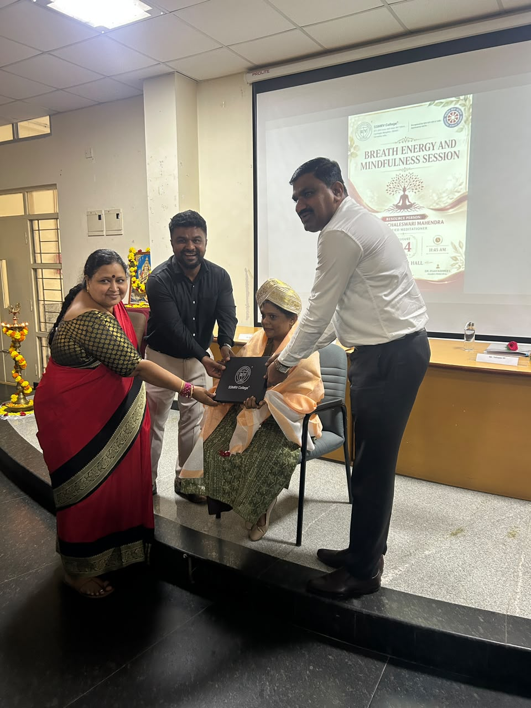
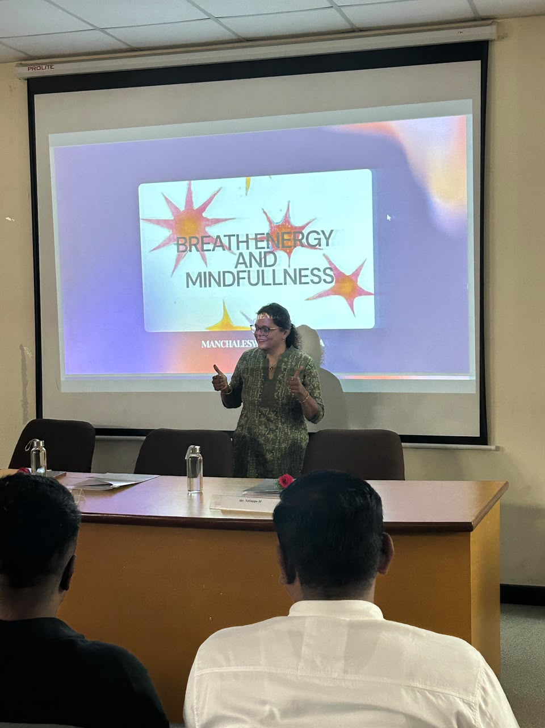

Activity Report

Academic year 2024-25
1.Basic details
Name of the Activity | WALK FOR BHARATH (WALKATHON)
Date | 11th August 2026
Time and Venue | 6:30 am – 10:00am Shalini Ground 5th block Jayanagar
Mode ( Online/Offline) | Offline
Organized by:  Name of the Department/Activity Centre | National Service Scheme(NSS UNIT)  Disha Bharath
Event Coordinator/ Faculty In-charge | Mr.Yallappa M  NSS Program Officer
Nature:  Academic /Co- curricular/extracurricular/others | Extracurricular
Topic/Activity | WALKATHON
Resource Person Details  (Name, Designation and Organization/Institution) | C K Ramaurthy , MLA Jayanagar  Mr. Yallappa M , NSS Program officer SSMRV COLLEGE
Participants | 100 Volunteers ( BCOM, BBA, BCA, BBA Aviation)
Objectives of the activity | The primary objective of the MY BHARATH WALKATHON was to inculcate a strong sense of patriotism, national pride, and social responsibility among college students on the occasion of the 80TH INDEPENDENCE DAY. The activity aimed to encourage youth participation in national celebrations, promote unity and national integration, create awareness about the duties and responsibilities of citizens, and inspire students to contribute positively to the development of the nation. It also sought to strengthen the values of discipline, teamwork, leadership, and community participation among NSS volunteers and students.
Methodology | The walkathon was organized by the NSS Unit of SSMRV College with active participation from college students. The Programe was planned and coordinated by the NSS team, with students assembled and briefed about the significance of Independence Day and the purpose of the walkathon. Participants marched in an organized and disciplined manner, carrying patriotic messages and demonstrating national pride throughout the activity. NSS volunteers assisted in maintaining coordination, discipline, and smooth conduct of the Programme. The activity was conducted as a collective youth movement to promote patriotism, unity, civic consciousness, and active citizenship.
Outcome of activity | The walkathon was organized by the NSS Unit of SSMRV College with active participation from college students. The programme was planned and coordinated by the NSS team, with students assembled and briefed about the significance of Independence Day and the purpose of the walkathon. Participants marched in an organized and disciplined manner, carrying patriotic messages and demonstrating national pride throughout the activity. NSS volunteers assisted in maintaining coordination, discipline, and smooth conduct of the programme. The activity was conducted as a collective youth movement to promote patriotism, unity, civic consciousness, and active citizenship.
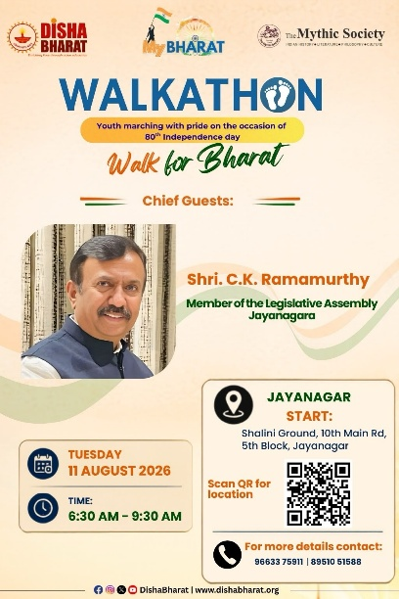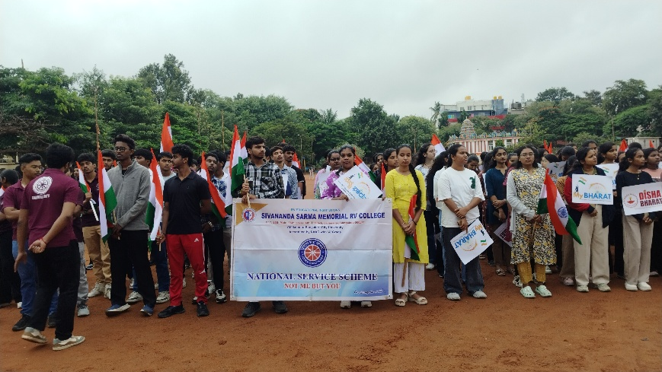

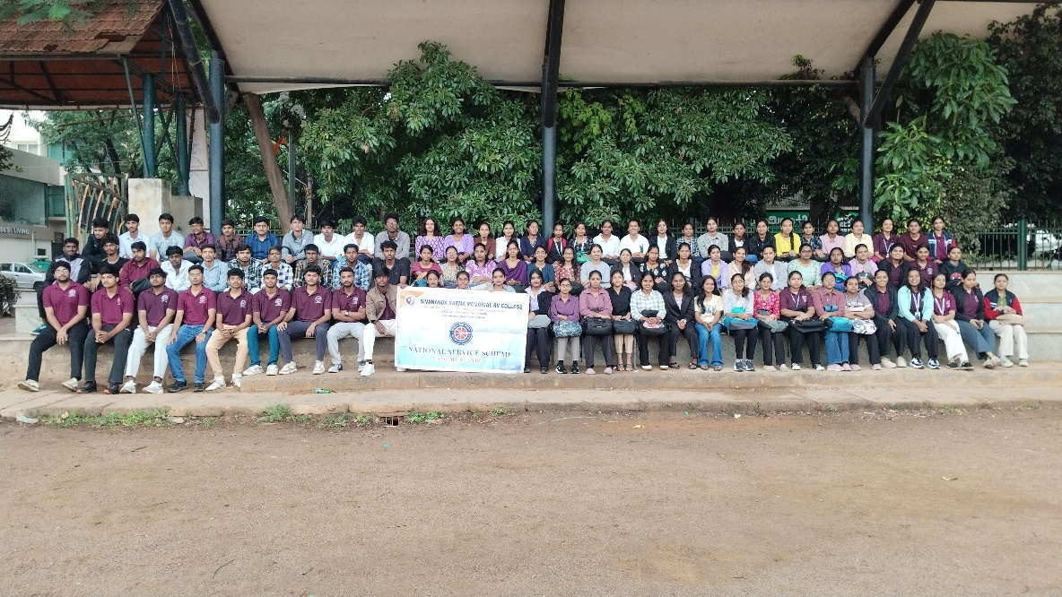

Activity Report

Academic year 2024-25
1.Basic details
Name of the Activity | 10th State Level Seminar On Transformation For The Nation
Date | 14th August 2026
Time and Venue | 09:00 am Sri. Puttanna Chetty Town Hall, Bengaluru
Mode ( Online/Offline) | Offline
Organized by:  Name of the Department/Activity Centre | National Service Scheme(NSS UNIT)  VISHWAMANYA YUVA VEDIKE & QUEEN’S GLOBAL MANAGEMENT SOLUTIONS
Event Coordinator/ Faculty In-charge | Mr.Yallappa M  NSS Program Officer
Nature:  Academic /Co- curricular/extracurricular/others | Extracurricular
Topic/Activity | 10th State Level Seminar On Transformation For The Nation
Resource Person Details  (Name, Designation and Organization/Institution) | Sri. Nichalanadanathan Mahaswamiji, Dr. Vijayalakshmi Balekundri, Ambassador Dr. Deepak Vohra, Sri Kamalkumar S, Ms. Jeevitha Mahendra, Dr. Hema Nandish, Sri. Vinay Patil
Participants | 25 Volunteers ( BCOM, BBA, BCA, BBA Aviation)
Objectives of the activity | The primary objective of the seminar was to develop a strong sense of social and national responsibility among college students and motivate them to become responsible and active citizens. The programme aimed to create awareness about the duties of youth towards society, encourage civic consciousness, promote leadership and teamwork, and inspire students to contribute positively to the social, economic and cultural development of the nation.
Methodology | The seminar was conducted through an interactive and participatory approach, bringing together college students at Town Hall. The programme included expert presentations, motivational interactions, awareness sessions and discussions focusing on nation-building, responsible citizenship and youth participation. Students were encouraged to actively engage in the sessions, reflect on their responsibilities towards society and identify meaningful ways through which they could contribute to community welfare and national development.
Outcome of activity | The seminar successfully enhanced students’ awareness of their responsibilities as citizens and their role in nation-building. Participants developed greater understanding of civic values, social commitment, leadership, and discipline and community participation. The programe motivated students to become more socially responsible and encouraged them to translate their learning into constructive actions for the welfare of society and the transformation of the nation.

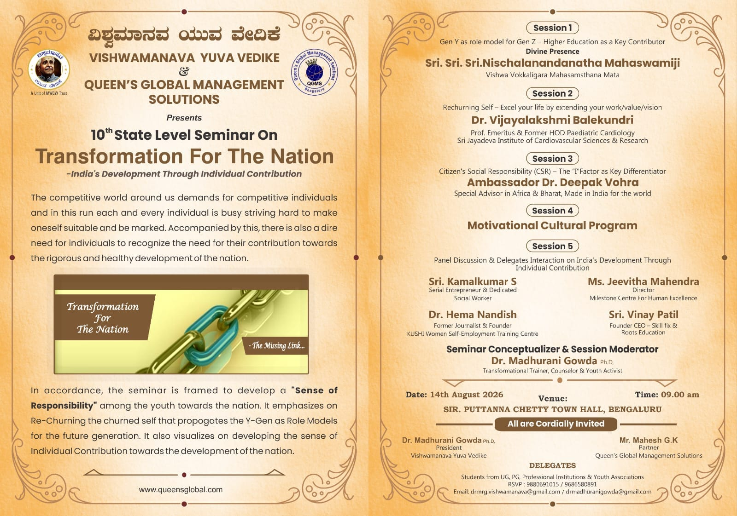
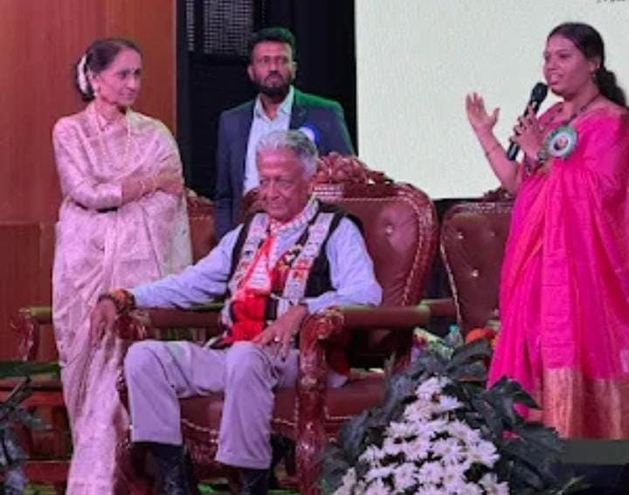
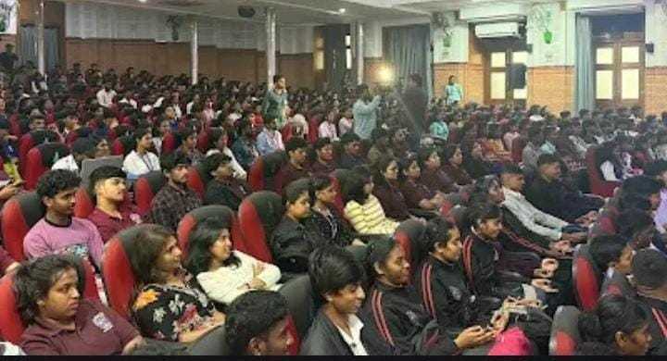

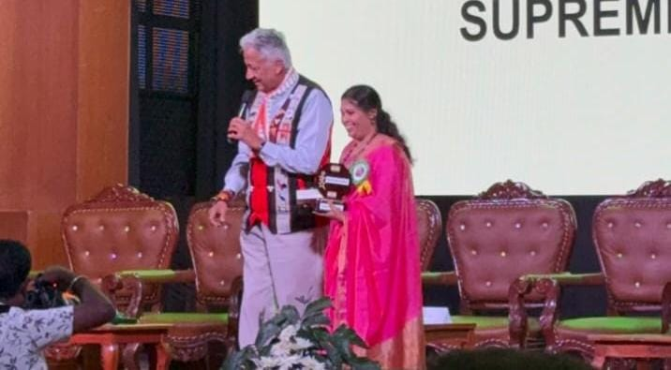

Activity Report

Academic year 2024-25
1.Basic details
Name of the Activity | 80th Independence Day Celebration
Date | 15th August 2026
Time and Venue | 7:30 AM at SSMRV College, Jayanagar Bengaluru
Mode ( Online/Offline) | Offline
Organized by:  Name of the Department/Activity Centre | National Service Scheme(NSS UNIT) &  National Cadet Cops (NCC)
Event Coordinator/ Faculty In-charge | Mr.Yallappa M  NSS Program Officer
Nature:  Academic /Co- curricular/extracurricular/others | Extracurricular
Topic/Activity | 80th Independence Day Celebration
Resource Person Details  (Name, Designation and Organization/Institution) | Major Vinita Thakur – Indian Army  Dr. Vijayashree L – SSMRV College Principal
Participants | 85 Volunteers ( BCOM, BBA, BCA, BBA Aviation)
Objectives of the activity | The primary objective of the activity was to inculcate a strong sense of patriotism, national responsibility, and respect for the values enshrined in the Constitution among students. The programme aimed to create awareness about the significance of India’s Independence Day, commemorate the sacrifices of freedom fighters, and encourage students to contribute positively towards nation-building. It also sought to promote unity, discipline, social responsibility, and the spirit of “Nation First” among the student community.
Methodology | The NSS Unit planned and coordinated the celebration with the active involvement of college students. Students were encouraged to participate in the various activities associated with the Independence Day programme, including patriotic presentations, cultural activities, and awareness-oriented engagements. NSS volunteers supported the organization and coordination of the event, ensuring disciplined participation and effective execution. The programme used participatory and experiential methods to help students connect the historical significance of independence with their present-day responsibilities as responsible citizens.
Outcome of activity | The celebration successfully created a strong sense of patriotism, unity, and civic consciousness among the participating students. Students gained a deeper understanding of the importance of India’s freedom struggle and the responsibilities associated with being citizens of a democratic nation. The programme also strengthened leadership, teamwork, discipline, and social commitment among NSS volunteers and participants. Overall, the event served as an effective platform for nurturing responsible youth committed to contributing to national development, social harmony, and the progress of the nation.

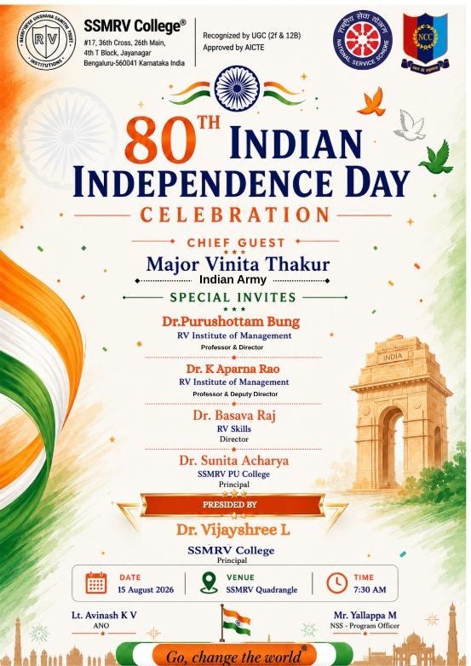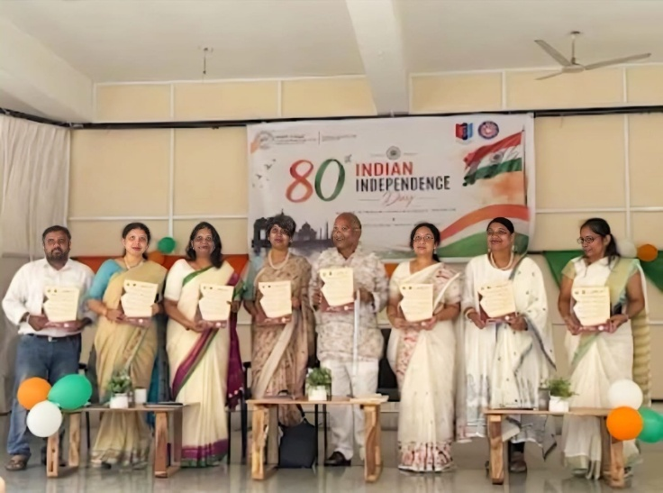
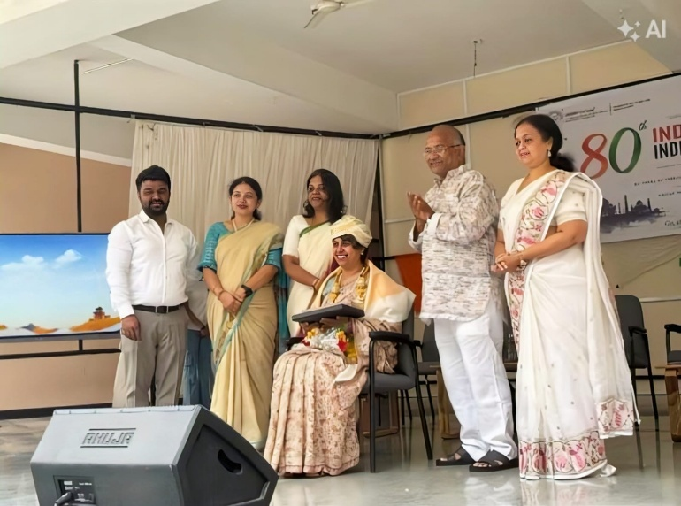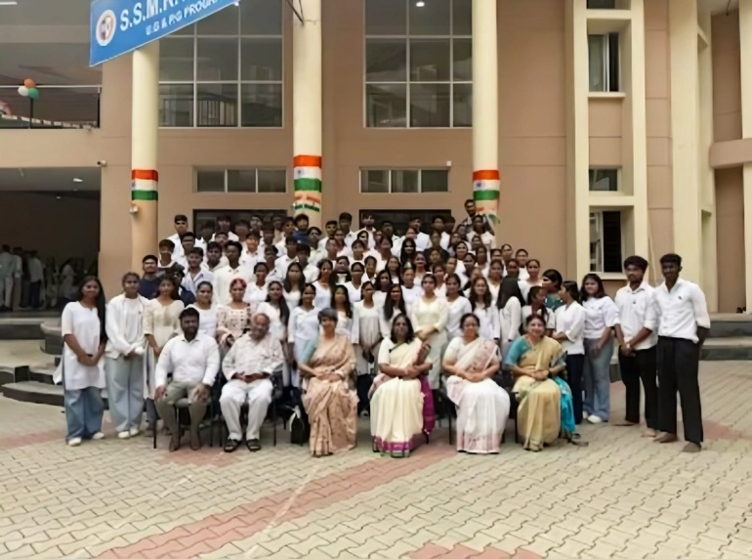
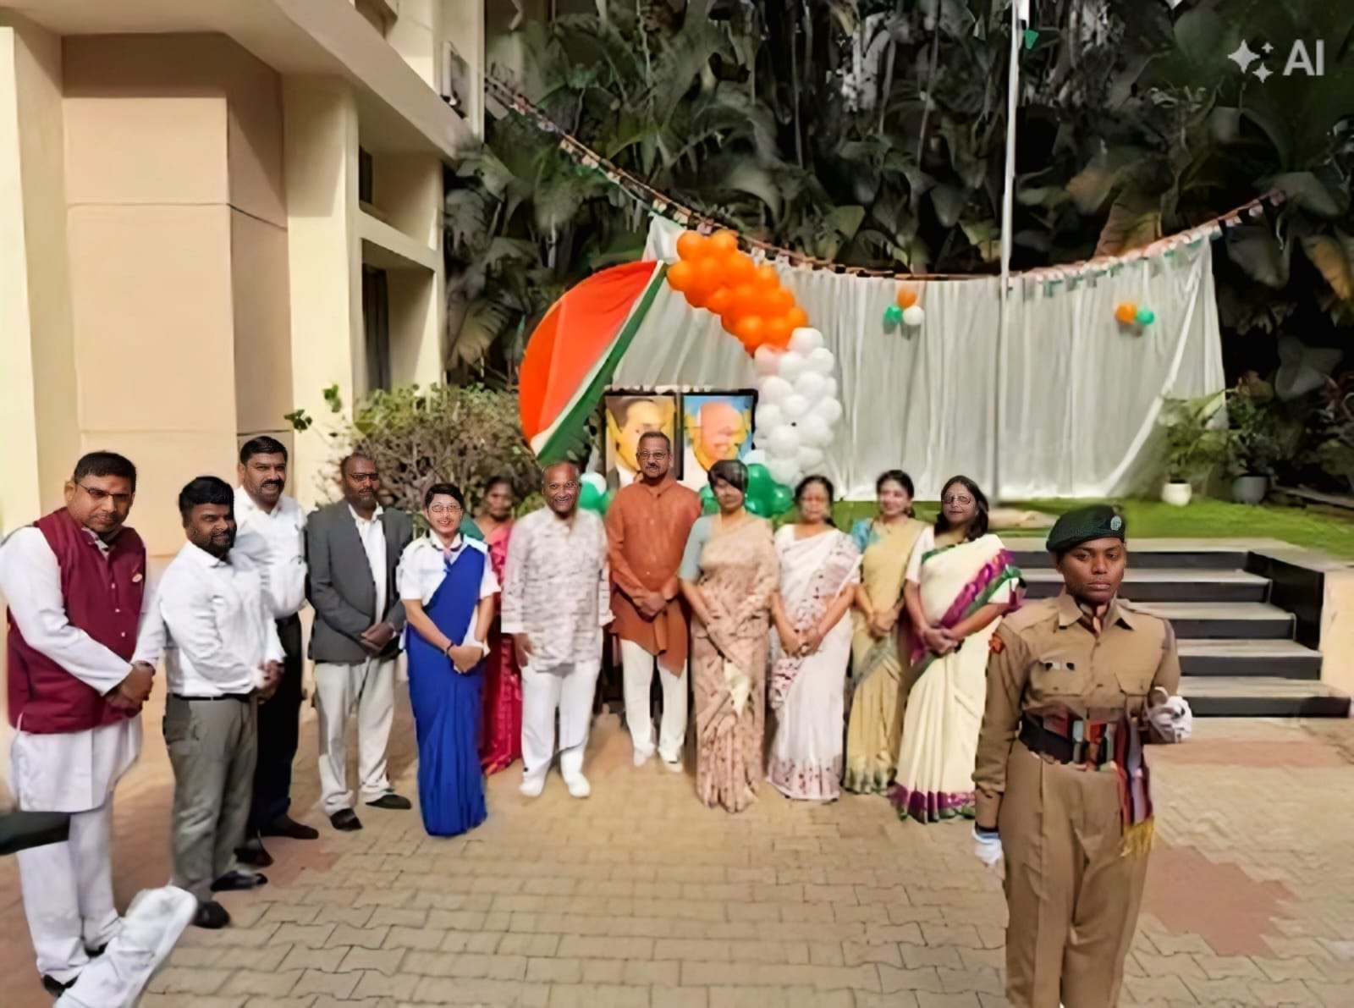

Activity Report

Academic year 2024-25
1.Basic details
Name of the Activity | NSS Inauguration 2026
Date | 19th September 2026
Time and Venue | !0:30 AM at SSMRV College, KG Subbarama Setty Auditorium, Jayanagar Bengaluru
Mode ( Online/Offline) | Offline
Organized by:  Name of the Department/Activity Centre | National Service Scheme(NSS UNIT)
Event Coordinator/ Faculty In-charge | Mr.Yallappa M  NSS Program Officer
Nature:  Academic /Co- curricular/extracurricular/others | Extracurricular
Topic/Activity | NSS Inauguration 2026
Resource Person Details  (Name, Designation and Organization/Institution) | Dr.B.Vasantha Shetty – (Deputy register,RGUHS)  Dr.HA.RA.Mahesh – (Social cultural writer & Resource Person)  Dr. Vijayashree L – SSMRV College Principal
Participants | 80 Volunteers ( BCOM, BBA, BCA, BBA Aviation)
Objectives of the activity | The objective of the NSS Inauguration Ceremony was to formally begin the NSS activities for the academic year 2026–27 and create awareness among students about the aims, objectives and responsibilities of NSS. The program aimed to motivate students to actively participate in community service, social welfare activities and nation-building program while developing leadership, teamwork, discipline and social responsibility.
Methodology | The NSS Inauguration Ceremony was organized at SSMRV College, Jayanagar, Bengaluru, with the participation of NSS volunteers, students, faculty members and invited dignitaries. The program commenced with a welcome address and formal inauguration, followed by an introduction to NSS activities and the responsibilities of volunteers. The dignitaries addressed the gathering and motivated students to actively involve themselves in community service and social development activities. The program concluded with a vote of thanks..
Outcome of activity | The program helped students understand the importance, objectives and activities of NSS and motivated them to actively participate in community service. It created awareness about social responsibility, leadership, teamwork and the spirit of volunteerism among the students. The inauguration also encouraged NSS volunteers to contribute positively to society and strengthened their commitment to the NSS motto, “Not Me But You.”

