YOGA & WELLNESS CLUB ORGANISES "AROGYA JINYASA" QUIZ COMPETITION, BADGING CEREMONY AND DISTRIBUTION OF CERTIFICATE OF APPRECIATION
The Yoga & Wellness Club of SSMRV College successfully organized "Arogya Jinyasa", a two-day inter-class quiz competition for I and II Year students of B.Com, BBA, and BCA programs on 29th and 30th September 2026 at the College Seminar Hall.
The event aimed to promote awareness of yoga, holistic wellness, healthy lifestyle practices, and mental well-being among students through an engaging and interactive learning experience. The competition was conducted in three exciting rounds: Quiz, Guess What?, and Rapid Fire, which witnessed enthusiastic participation from students across various departments.
As part of the occasion, a Membership Badging Ceremony was conducted to core student members of the Yoga & Wellness Club. The badges were presented to the members in recognition of their commitment towards promoting wellness initiatives and participating actively in club activities throughout the academic year.
The event also featured the distribution of Certificates of Appreciation to the Core Members of the Yoga & Wellness Club in acknowledgment of their dedication, leadership, and valuable contribution towards planning and organizing various club activities. The certificates were presented as a token of gratitude for their efforts in fostering a culture of health, mindfulness, and wellness within the institution.
The programme was conducted under the guidance of Ms. Roopa Latha M, Convener, Yoga & Wellness Club, and with the encouragement and support of Dr. Vijayasree L, Principal, SSMRV College. The event concluded successfully with active student participation, creating awareness about the significance of yoga and wellness in everyday life.
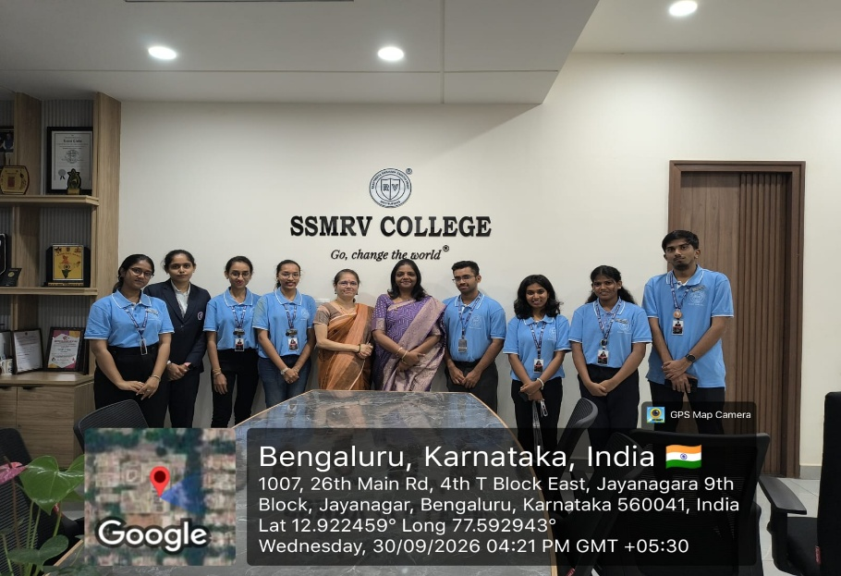
Badging for Core members

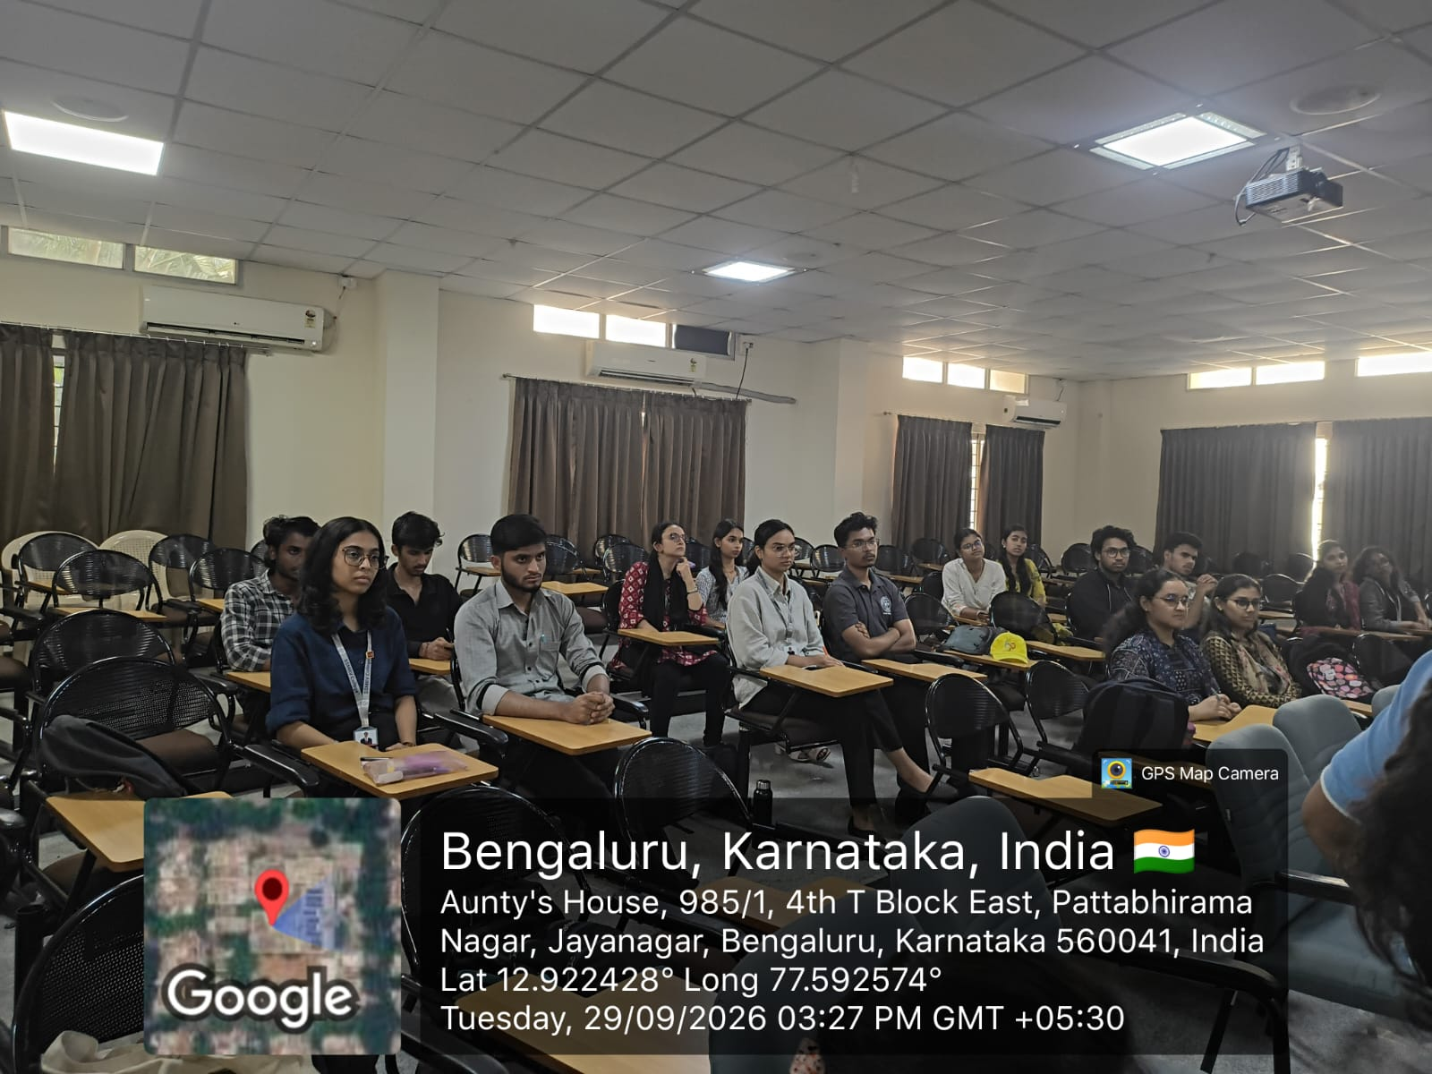
Participants in the Quiz competiti

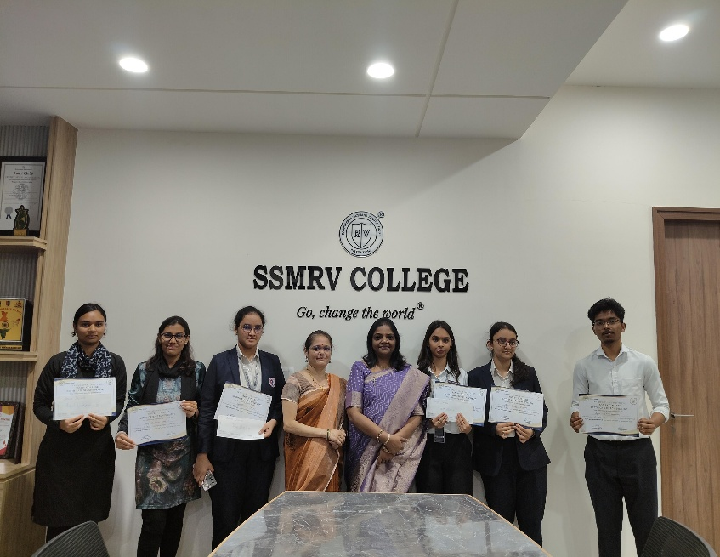
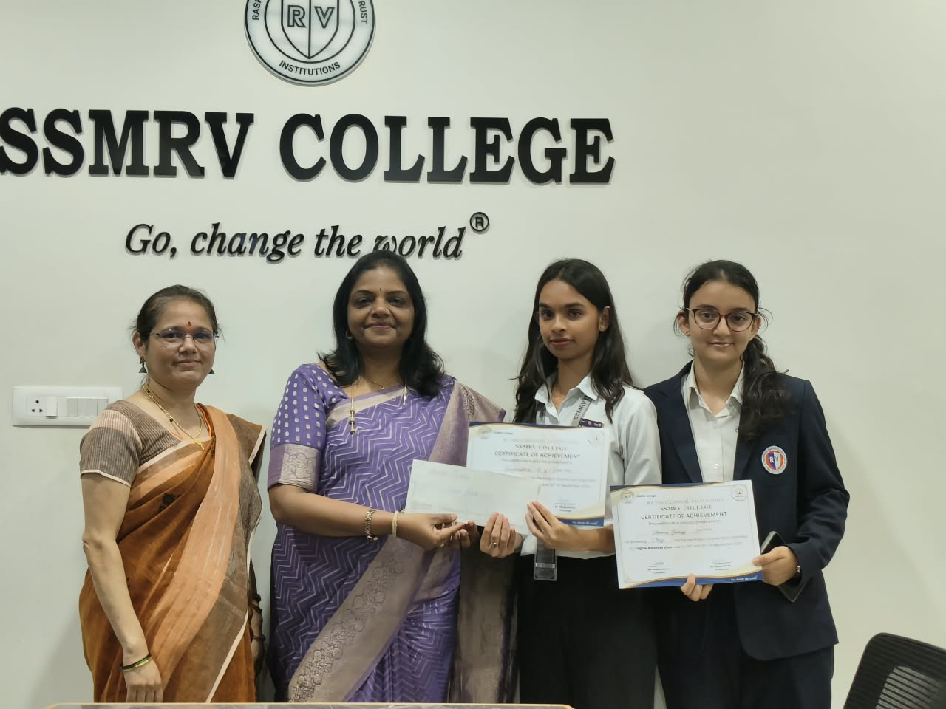 First prize winner
Winners of the competition

